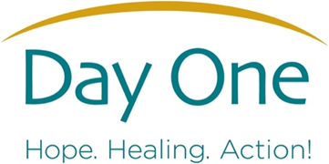

Informing, Educating, Healing Together in…

Families Supporting Children (FSC)
Formerly known as Non-Offending Parent Group (NOP)

A psychoeducational group for Parents/Caregivers/Families impacted by
the sexual abuse of their children

It can be a very difficult time when you or your family learns that your child has experienced sexual abuse, most likely by someone you knew and trusted!
We invite you to join an 8-week group with the goals to provide important education and information to support you and your family. The information below offers the agenda for each week so that you can best support your child and family in their healing process.
To complete this group, attendance is necessary. Please call to schedule your group screening.
Where: Day One
Time: Tuesdays from 6:00-7:30; Next Round Beginning in June 2026
Contact: Grimary Español Reyes, Clinical Intake Coordinator, 401-421-4100 ext. 121; gespanol@dayoneri.org

Week One: | Beginning Our Journey Together
Week Two: | Overview of Child Sexual Abuse
Week Three: | Coping and Communication
Week Four: | How Abuse Affects Children and Teens
Week Five: | How Abuse Affects Parents and Siblings
Week Six: | Difficult Childhood Behaviors and Parenting Challenges
Week Seven: | Dealing with the Outside World
Week Eight: | Moving into the Future

Please Note: If you miss more than two sessions, you will not be able to continue, however, you are welcome to join again in the following round.

